CapStone Project (Multi-Tier Website Deployment)

Architecture Diagram

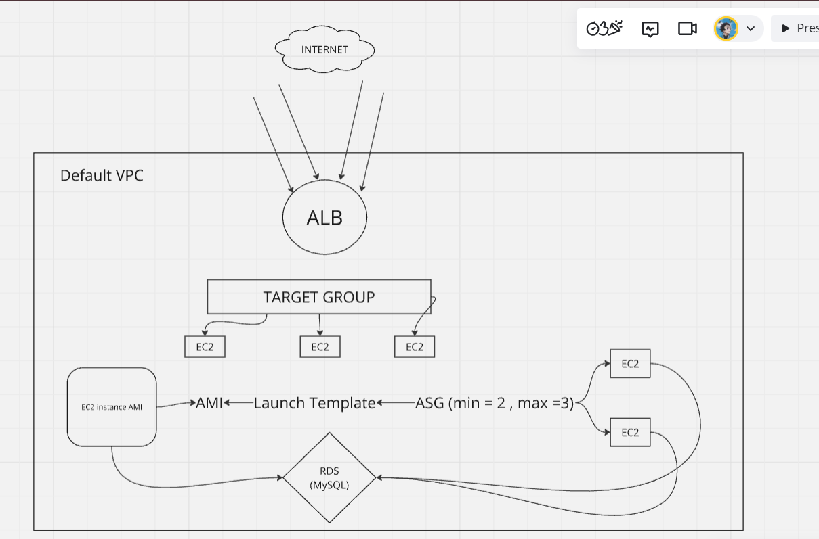

Copied code.zip file to EC2 instance launched.

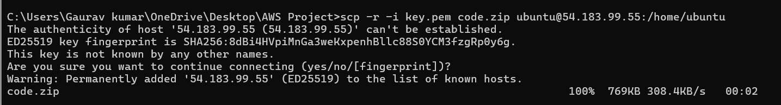

Extracted the code and moved the file from 1234 dir to **/var/www/html**

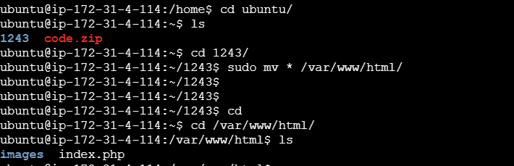

After changing the file in /var/www/html, we are able to land on website for which the code was provided.

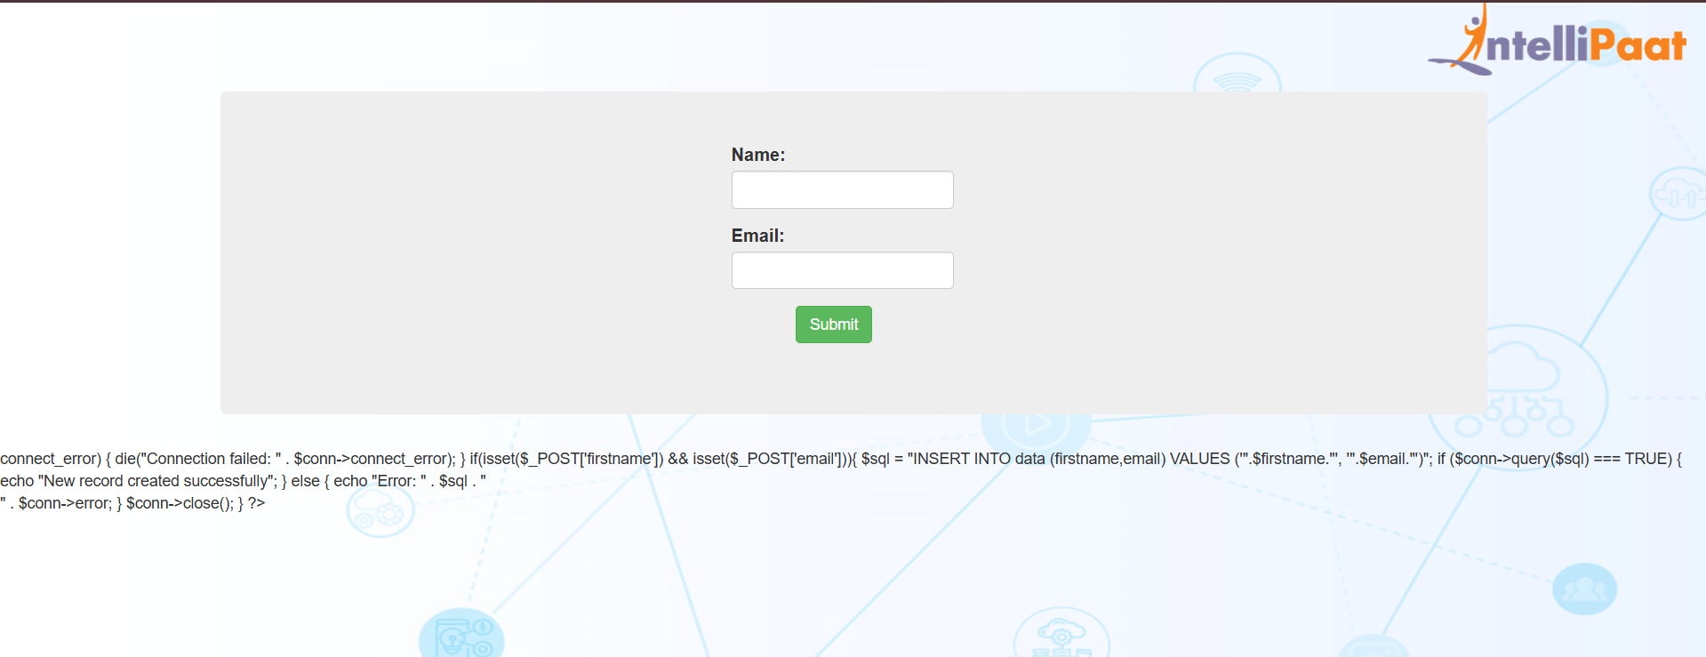

Launching a new RDS MySQL db instance and connecting it via EC2 instance

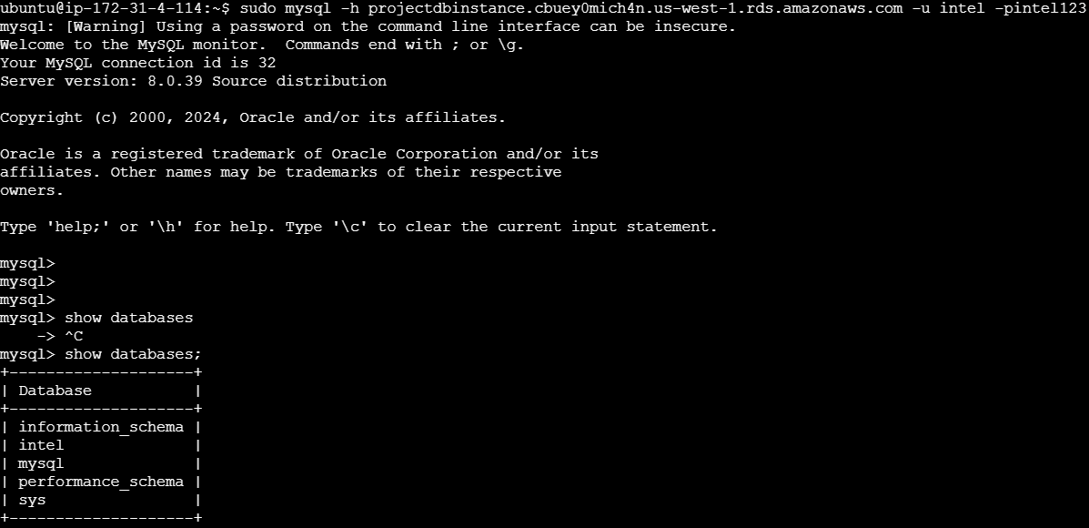

Created table data with fields ( firstname / email )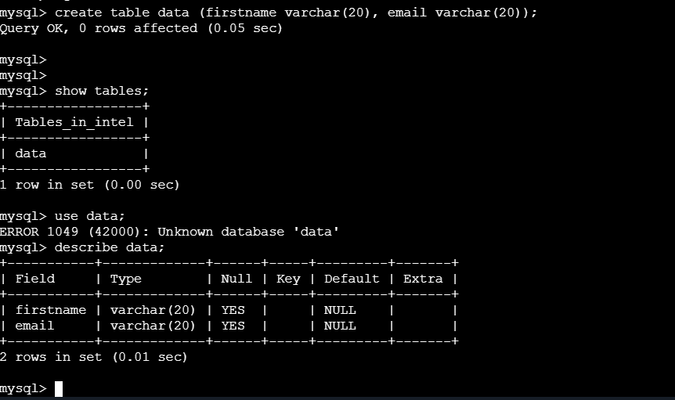

After changing the configuration in php file where we added the RDS instance endpoint we are able to run the application. The records are getting published now.



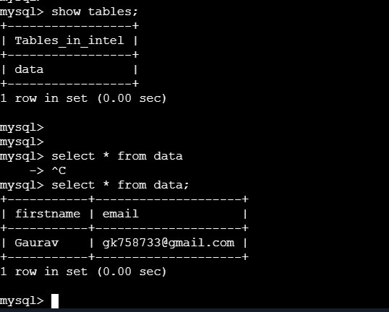

Created new ASG with min –> 2 and max –> 3

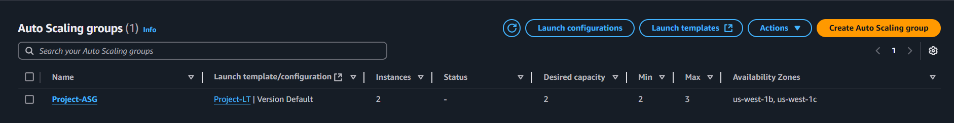



Now using the ALB endpoint we can run the website.